ACME Insurance Company Database Management Program

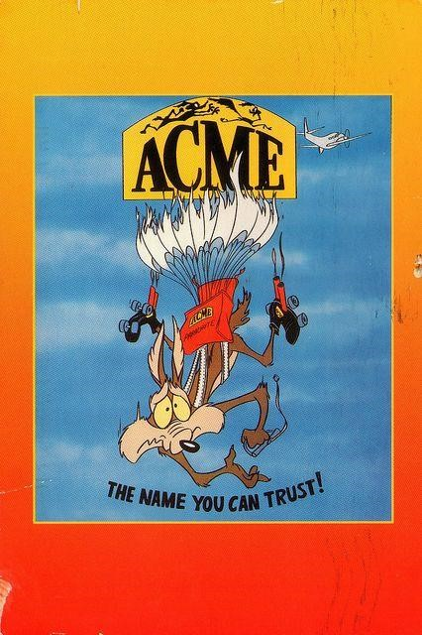

Unleased Business Solutions 2019 ©

Table of Contents

Overview 3

Tutorial 4

1. Customers 4

View customers 4

Add a new customer 5

Update customer details 5

Search customer records 6

Delete customer record 7

2. Categories 9

View categories 9

Add a new category 9

Update category details 10

Search category records 11

Delete category 12

3. Products 13

View products 13

Add new product 14

Update product details 15

Search product records 16

Delete product 17

4. Product Types 18

View product types 18

Add new product type 18

Update product type details 19

Search product type records 20

Delete product type 21

5. Sales 22

View sales 22

Add new sale 23

Update sale details 24

Search sale records 25

Delete sale 26

# Overview

This tutorial demonstrates how view and maintain records stored on ACME Insurance Company’s database using the Database Management Program. The tutorial is divided into sections;

1. Customers
2. Categories
3. Products
4. Product Types
5. Sales

Each section will describe how to view and maintain each entity. File and help menu can also be accessed from each entity view screen.

# Tutorial

# Customers

## View Customers

1. Select File > Customers

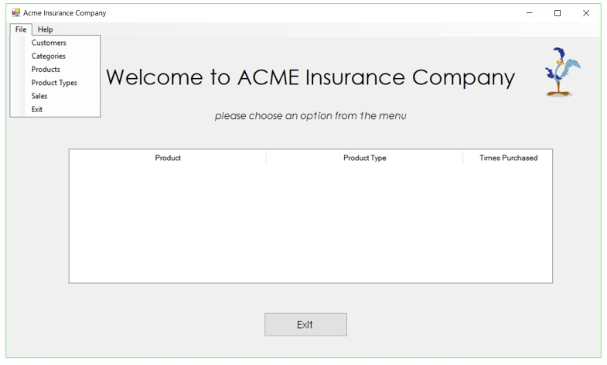

1. View Customers Details screen will be displayed

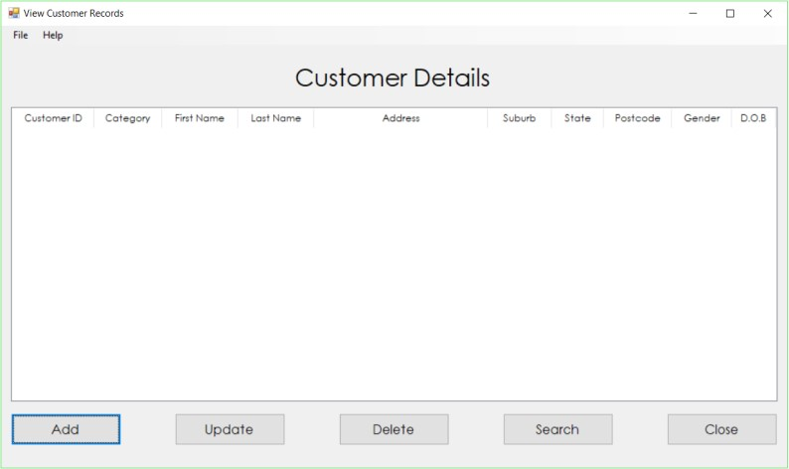

## Add a new customer

1. Select File > Customers
2. View Customer Details screen is displayed
3. Select Add - Add New Customer screen is displayed



1. Enter new customer details

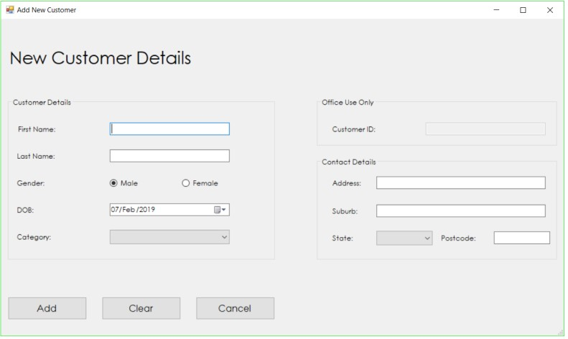

1. Select

5a. Add – Adds new customer to the database

5b. Clear – Clears all entered data on the screen

5c. Cancel – Closes screen and returns to View Customer Details screen

## Update customer details

1. Select File > Customers
2. View Customer Details screen is displayed

1. Highlight the customer you wish to edit and select Update



1. Edit Customer Details screen is displayed preloaded with the chosen customer’s information

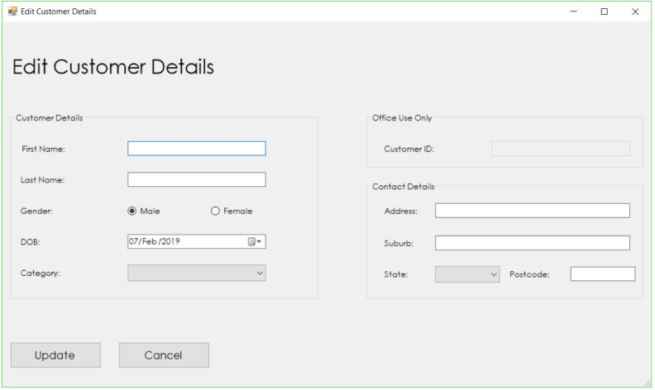

1. Once customer details have been updated, select

5a. Update - Apply changes made to the selected customer’s record

5b. Cancel – Closes screen and returns to View Customer Details screen

## Search customer records

1. Select File > Customers

1. View Customer Details screen is displayed
2. Select Search



1. Search Customer Records screen is displayed

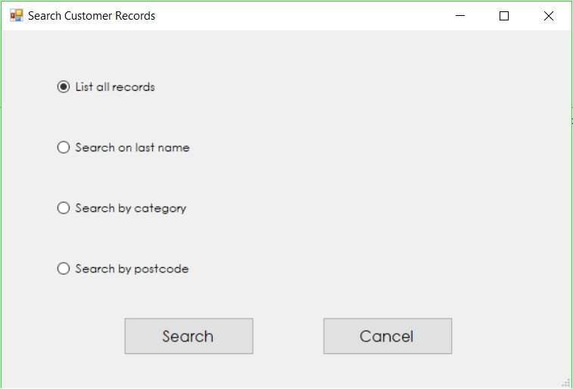

1. Select search criteria

5a. List all records

5b. Search on last name

5c. Search by category

5d. Search by postcode

1. Select

6a. Search - Displays records that match search criteria

6b. Cancel – Closes screen and returns to View Customer Details screen

## Delete customer record

1. Select File > Customers
2. View Customer Details screen is displayed

1. Highlight the customer you wish to edit and select Delete



1. Confirmation message will be shown, select

4a. Yes – Deletes the selected customer from database

4b. No – Cancels deletion of customer record

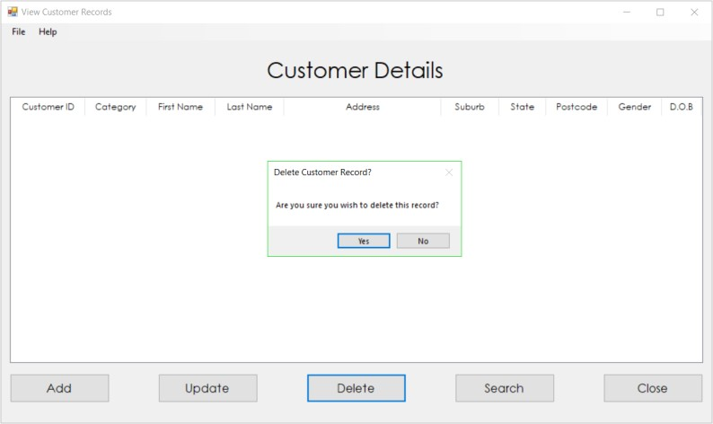

# Categories

## View categories

1. Select File > Categories



1. View Categories screen will be displayed

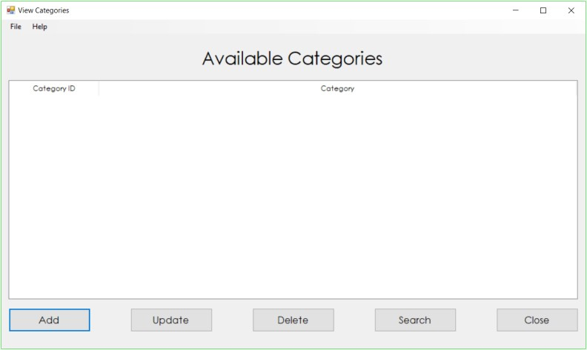

## Add a new category

1. Select File > Categories
2. View Categories screen is displayed

1. Select Add - Add New Category screen is displayed

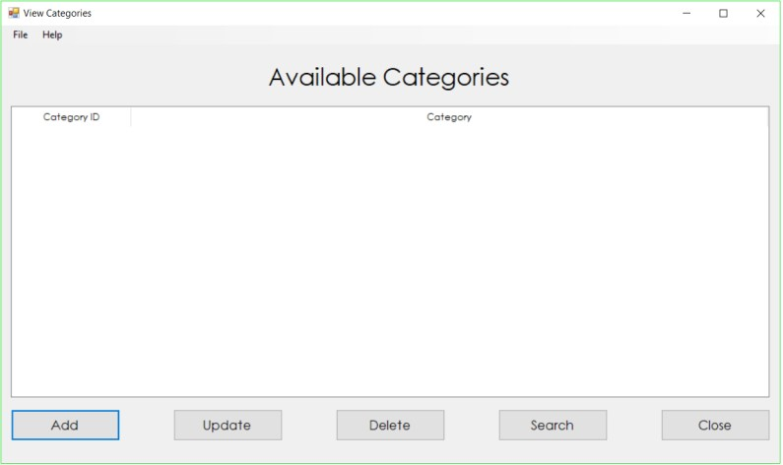

1. Enter new category details

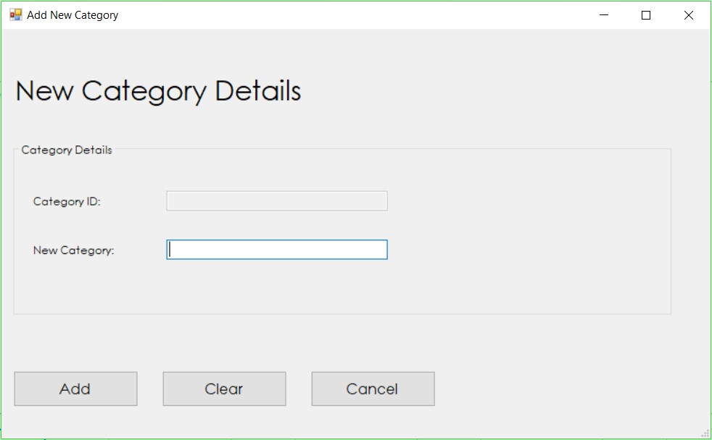

1. Select

5a. Add – Adds new category to the database

5b. Clear – Clears all entered data on the screen

5c. Cancel – Closes screen and returns to View Category screen

## Update category details

1. Select File > Category
2. View Categories screen is displayed

1. Highlight the category you wish to edit and select Update



1. Edit Category Details screen is displayed preloaded with the chosen category’s information

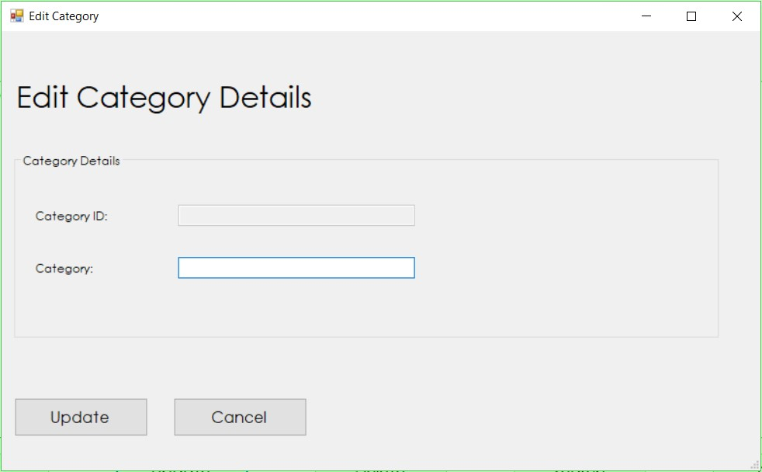

1. Once category details have been updated, select

5a. Update - Apply changes made to the selected category

5b. Cancel – Closes screen and returns to View Category screen

## Search category records

1. Select File > Categories
2. View Categories screen is displayed

1. Select Search



1. Search Categories screen is displayed

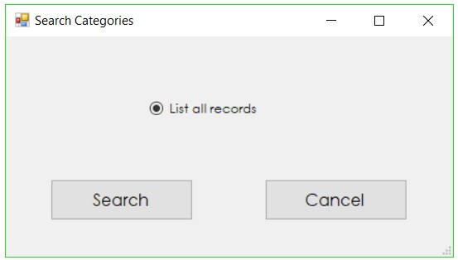

1. Select search criteria

5a. List all records

1. Select

6a. Search - Displays records that match search criteria

6b. Cancel – Closes screen and returns to View Customer Details screen

## Delete category

1. Select File > Categories
2. View Categories screen is displayed

1. Highlight the category you wish to remove and select Delete



1. If the category is currently tied to data present in the system, the user will be prompted with a message “Cannot delete category, category is being used”. Click OK to return to View Categories screen

1. If category can be successfully deleted, a confirmation message will be shown, select

5a. Yes – Deletes the selected category from database

5b. No – Cancels deletion of category

# Products

## View products

1. Select File > Products



1. View Products screen is displayed

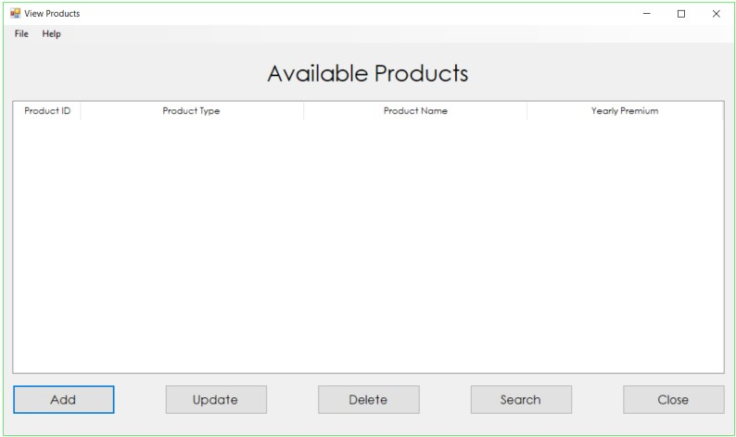

## Add new product

1. Select File > Products
2. View Products screen is displayed
3. Select Add - Add New Product screen is displayed



1. Enter new product details

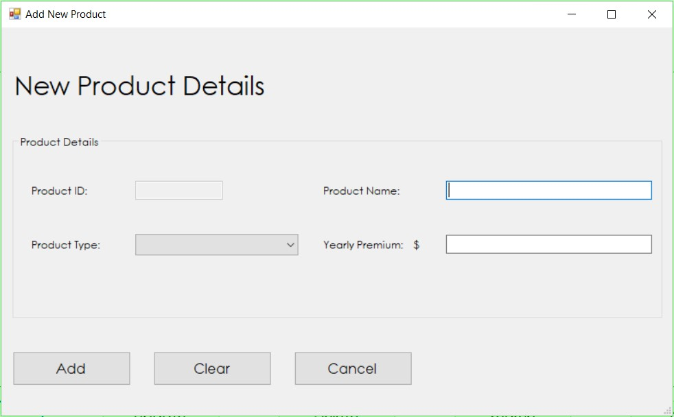

1. Select

5a. Add – Adds new product to the database

5b. Clear – Clears all entered data on the screen

5c. Cancel – Closes screen and returns to View Products screen

## Update product details

1. Select File > Products
2. View Productsscreen is displayed
3. Highlight the product you wish to edit and select Update



1. Edit ProductDetails screen is displayed preloaded with the chosen products’ information

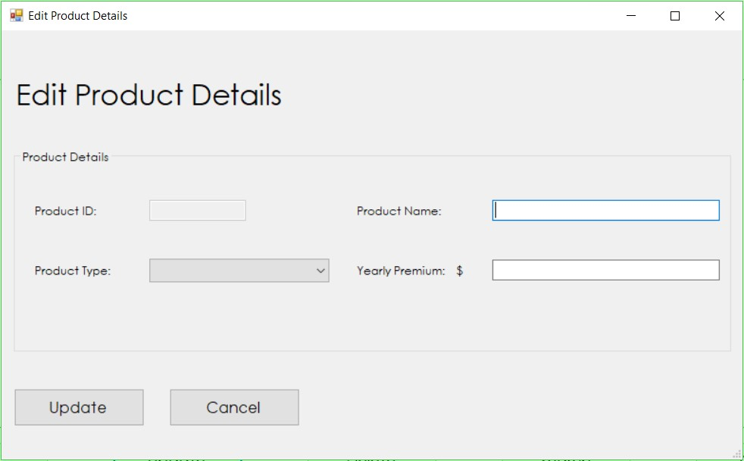

1. Once the product’s details have been updated, select

5a. Update – Apply changes made to the selected product

5b. Cancel – Closes screen and returns to View Products screen

## Search product records

1. Select File > Products
2. View Products screen is displayed
3. Select Search



1. Search Products screen is displayed

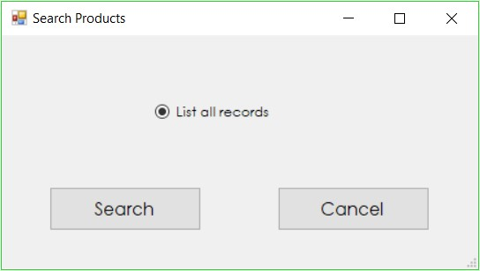

1. Select search criteria

5a. List all records

1. Select

6a. Search - Displays records that match search criteria

6b. Cancel – Closes screen and returns to View Products screen

## Delete product

1. Select File > Products
2. View Products screen is displayed
3. Highlight the product you wish to remove and select Delete



1. If the product is currently tied to data present in the system, the user will be prompted with a message “Cannot delete product, product is being used”. Click OK to return to View Products screen

1. If the product can be successfully deleted, a confirmation message will be shown, select

5a. Yes – Deletes the selected product from database

5b. No – Cancels deletion of the product

# Product Types

## View product types

1. Select File > Product Types



1. View Product Typesscreen is displayed

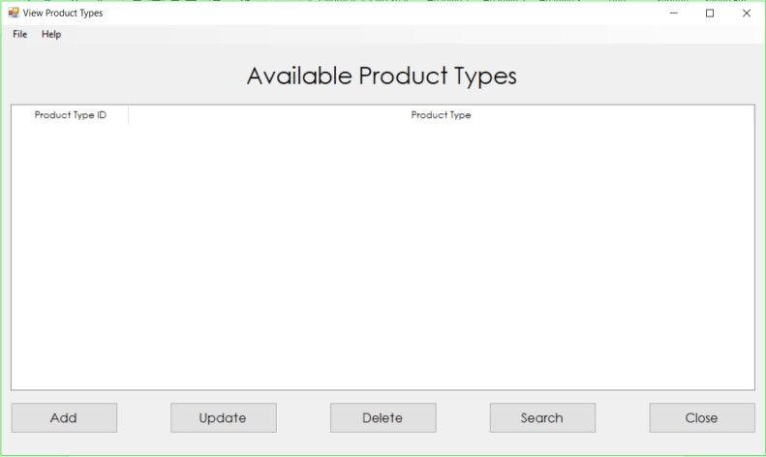

## Add new product type

1. Select File > Product Types
2. View Product Typesscreen is displayed

1. Select Add – Add New Product Typescreen is displayed



1. Enter new product typedetails

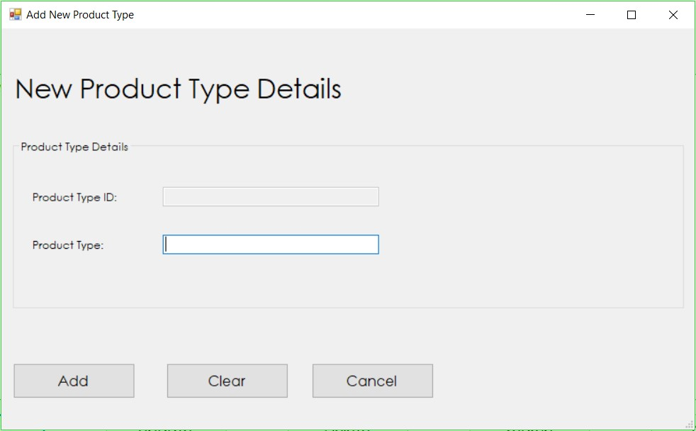

1. Select

5a. Add – Adds new product type to the database

5b. Clear – Clears all entered text on the screen

5c. Cancel – Closes screen and returns to View Product Types screen

## Update product type details

1. Select File > Product Types
2. View Product Typesscreen is displayed

1. Highlight the product type you wish to edit and select Update



1. Edit Product TypeDetails screen is displayed preloaded with the chosen product type’s information

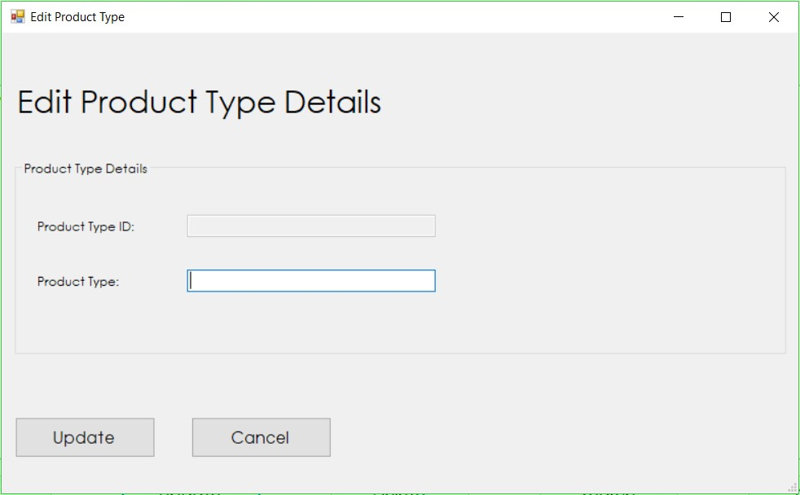

1. Once the product type’s details have been updated, select

5a. Update – Apply changes made to the selected product type

5b. Cancel – Closes screen and returns to View Product Types screen

## Search product type records

1. Select File > Product Types
2. View Product Types screen is displayed

1. Select Search



1. Search Product Types screen is displayed

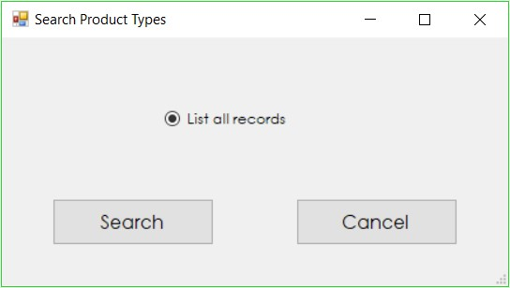

1. Select search criteria

5a. List all records

1. Select

6a. Search - Displays records that match search criteria

6b. Cancel – Closes screen and returns to View Product Types screen

## Delete product type

1. Select File > Product Types
2. View Product Types screen is displayed

1. Highlight the product type you wish to remove and select Delete



1. If the product type is currently tied to data present in the system, the user will be prompted with a message “Cannot delete product type, product type is being used”. Click OK to return to View Product Types screen

1. If the product type can be successfully deleted, a confirmation message will be shown, select

5a. Yes – Deletes the selected product type from database

5b. No – Cancels deletion of product type

# Sales

## View sales

1. Select File > Sales



1. View Sales Recordsscreen is displayed

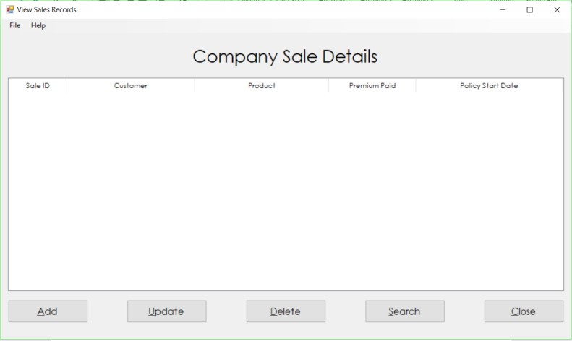

# Add new sale

1. Select File > Sales
2. View Sales Recordsscreen is displayed
3. Select Add – Add New Salescreen is displayed



1. Enter new saledetails

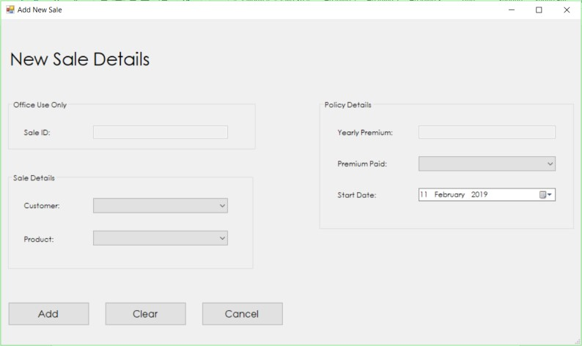

1. Select

5a. Add – Adds the new sale to the database

5b. Clear – Clears all entered text on the screen

5c. Cancel – Closes screen and returns to View Sale Records screen

# Update sale details

1. Select File > Sales
2. View Sale Recordsscreen is displayed
3. Highlight the sale record you wish to edit and select Update



1. Edit SaleDetails screen is displayed preloaded with the chosen sale’s information

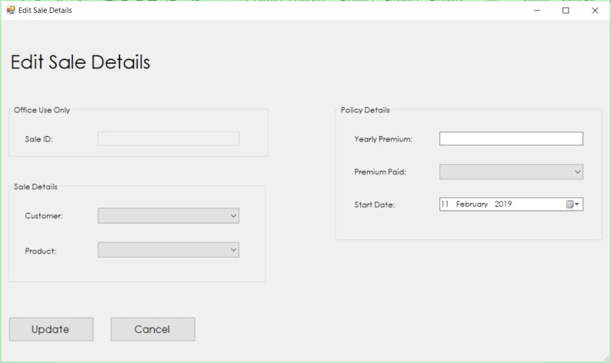

1. Once the sale’s details have been updated, select

5a. Update – Apply changes made to the selected sales record

5b. Cancel – Closes screen and returns to View Sale Records screen

# Search sale records

1. Select File > Sales
2. View Sale Records screen is displayed
3. Select Search



1. Search Sale Records screen is displayed

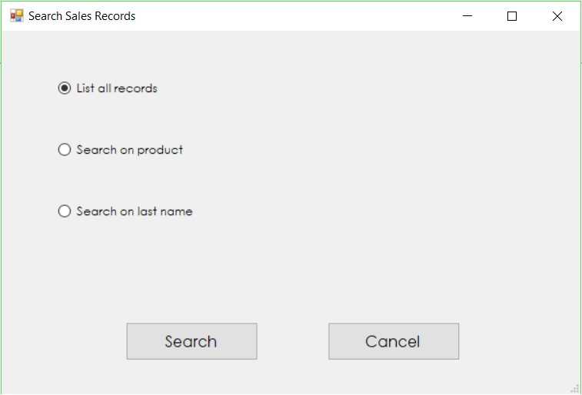

1. Select search criteria

5a. List all records

5b. Search on product

5c. Search on last name

1. Select

6a. Search - Displays records that match search criteria

6b. Cancel – Closes screen and returns to View Sales Records screen

# Delete sale

1. Select File > Sales
2. View Sale Records screen is displayed
3. Highlight the ### you wish to remove and select Delete *(show screen)*



1. Confirmation message will be shown, select

4a. Yes – Deletes sale from database

4b. No – Cancels deletion of sale record

